Great Wilbraham Residents Survey

Construction of an East West Rail Train Care Centre in Fulbourn

Why are you receiving this?

You may be aware that there are plans, as part of the East West Rail (EWR) project to connect Cambridge with Oxford, to build a train care centre (TCC) on the Great Wilbraham side of Fulbourn (behind Ernest Doe’s). The latest consultation document, which includes this new proposal, ‘landed’ on 14th April. We must respond by 9th June. You can read it here: https://eastwestrail.co.uk/consultation/consultation2026.

Please consider responding to the consultation yourself.

In developing applications for the changes made to our village roads in recent years, we have learned that demonstrating the strength of feeling amongst local residents can be a powerful tool. We would like to do that again, since the construction of the EWR facility in Fulbourn will have a serious impact on our village.

A few facts …..

EWR has been developing proposals for this project since before 2019, when they launched the first of their consultation documents. The most recent consultation will be the last, as EWR plan to apply to the Government to proceed with the construction next year.

The company will build two “train care centres” (TCCs) close to each end of the line. The preferred location for the Eastern TCC is in Fulbourn, on the Great Wilbraham side of the railway crossing.

The TCC is where trains will be cleaned, serviced and kept overnight. EWR proposes that the Fulbourn site will include 6 stabling tracks (up to 250 metres long), facilities for train cleaning, toilet emptying and the replenishment of materials, staff welfare facilities, lit walkways, road access and car parking.
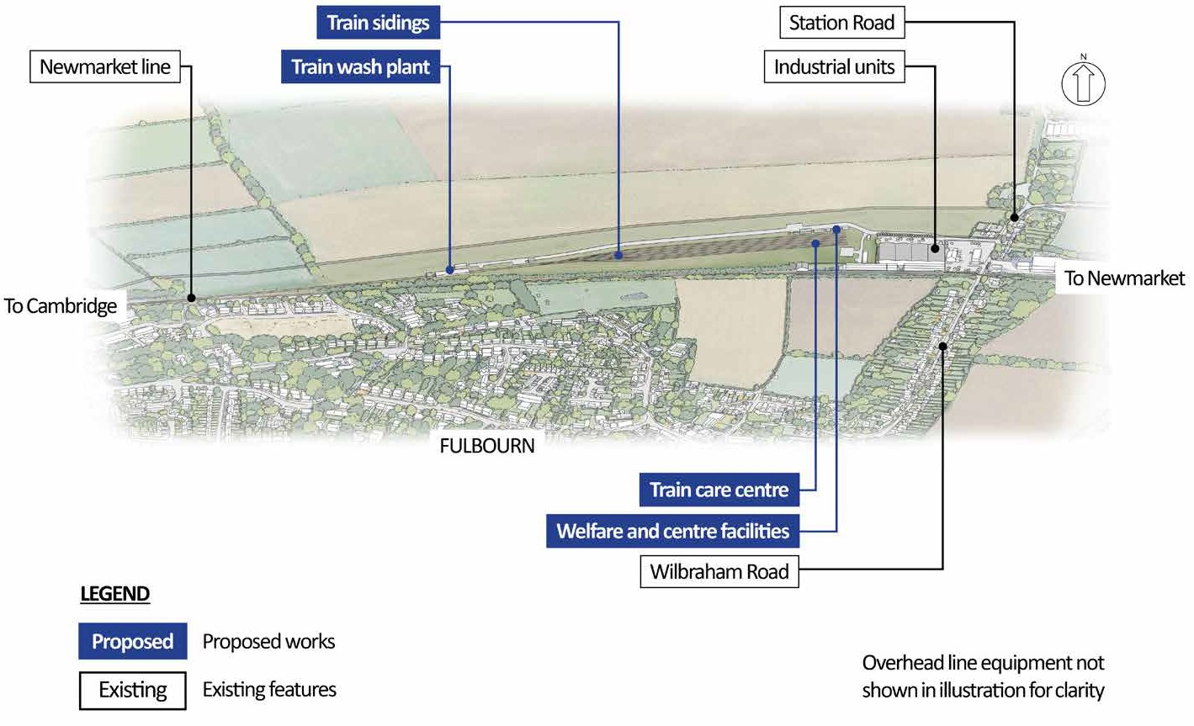

EWR estimates that it will take 3 years to construct the TCC, and the current plan is that all of the construction traffic will be routed to and from the A11 via Great Wilbraham. We face the prospect of large HGVs carrying everything needed first to remove the spoil and then to build the facility. All this two-way traffic will travel up and down Mill Road, the High Street, Frog End and Station Road for at least 3 years. In the longer term, if the site is adopted, there will be an increase of traffic at night for those servicing the facility.

You can help us to influence these plans

Please complete and return the questionnaire overleaf to us by Sunday 31st May at the very latest, enabling us to refer to your opinions and ideas in the Parish Council’s response to the Consultation.

You can post responses at 16 Church Street, 25 Frog End or at the Post Office.

You can also respond online by scanning the QR code.

Great Wilbraham Residents Survey – Fill out form

Name ………………………………………………………………….…… Email address………………………………………….………………………………

Address ………………………………………………………………………………………………………………………………………………………………..

No. | Information | Questions | Y/N | *Comments
1 | The East West Rail (EWR) project has been under development for more than 5 years, with consultations in 2019, 2021and 2024. | Were you aware that the EWR project would affect GW, prior to receiving this communication? | Yes
1 |  |  | No
2 | East West Rail estimate that the TCC will take 3 years to build, and that heavy and lengthy construction supplies will be transported by HGVs via the A11, Mill Road and through the southern end of GW. | Does this worry you?  *If so, please tell us why. | Yes
2 |  | Does this worry you?  *If so, please tell us why. | No
3 | EWR has made no detailed on-site survey of the route – which includes roads too narrow to enable HGVs to pass, junctions unsafe for long vehicles to turn, stretches of single carriageway and roads within the village where residents park. There are also many homes including listed houses adjacent to, and infrastructure under, the carriageways. | Do you consider that the suggested route uses roads that can safely be navigated by HGVs?  *If yes, please describe the aspects of the route that you consider to be unsuitable or unsafe, and any other areas of concern. | Yes
3 |  |  | No
4 | If the project goes ahead, additional temporary and/or permanent changes to the local road network may be required to accommodate construction HGVs. | *What would, or would you not, like to see? | N/A
5 | Large scale construction projects sometimes fund projects to benefit local residents, as compensation for the disruption they suffer. One idea is the funding of cycle lanes to adjacent villages. | Do you have any other ideas about what we might seek to benefit the village?  *If so, please tell us your ideas. | Yes
5 |  |  | No

* Please add any further comments on a separate sheet of paper

