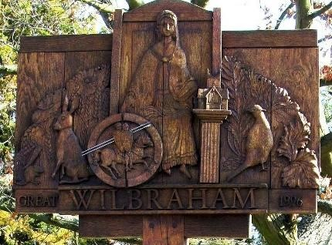
GREAT WILBRAHAM PARISH COUNCIL
Chairman: Dr Hilary Burton. Clerk: Mrs Sam Chambers-Turner
41 Stow Road, Stow-Cum-Quy
CB25 9AD
Tel: 07369248998
Email: clerk@greatwilbrahamparishcouncil.gov.uk

NOTICE OF THE ANNUAL PARISH MEETING OF GREAT WILBRAHAM

AGENDA

Monday 18th May 2026 at 7.30 pm

(Refreshments are available from 7.00 pm)

- Welcome and introductions to Parish Councillors
- Reports and updates from the Chairman of the Parish Council, Chairman of the Highways, Transport and Cycleways Committee and the Chairman of the Environment and Biodiversity Group.
Each followed by an opportunity to ask questions and make suggestions.
- Report and update from County and District Councillors
Each followed by an opportunity to ask questions.
- Roundtable discussions on key village topics.
An opportunity to meet other residents, representatives of village organisations and Councillors, discuss important upcoming issues and raise any other concerns or ideas.
- Feedback, and discussion of next steps.
- Close of meeting at 9.30 pm followed by informal discussion.

Hilary Burton
Chairman
7 April 2025

