Great Wilbraham organisations and societies: survey responses

In preparation for the Annual Parish meeting, organisations and societies operational in GW were approached to ask if they would like to provide information, including filling in a questionnaire about their activities and achievements in the past year and their plans for the future. Replies were received from 18 organisations, interest groups and clubs, focusing on well-being, social, sport and special interests, the environment and traffic or those having a supporting role in village life. Table 1 includes information on membership numbers.

1 Responses received and membership.

Over60s | 73
Transport Working Group | 10
Wilbraham’ Warbler
Wilbrahams Environment Group | 90
Bridge club | 20
Patchwork and Quilting Group | 25 - 30
Wilbrahams Social Club | 150
Wilbrahams’ Community Choir | 35
Wilbrahams' Memorial Hall | 12 Management Committee; 54 named volunteers not including the committee.
Great Wilbraham Guild of Change Ringers | 9
Wilbrahams Sports Club | 80 + not including the many who come to watch
The Wilbrahams and Six Mile Bottom Vegetable Flower and Produce Show | There are 12 team members
Well-brahams | 8
Great Wilbraham Common Rightsholders | 26
Over60s | 73
Transport Working Group | 10
Wilbraham Rivers Protection | 150
Scrabble | 16

2 Achievements

Over60s | Hopefully stopping isolation of older people | Entertainment
Transport Working Group | Successful LHI Application for zebra crossing outside school | MVAS Units. Volunteer teams moving units and collecting data to provide support for HTCC and to advise on traffic issues generally. | Working with HTCC and police for the establishment of the Speedwatch surveys.
Wilbrahams Environment Group | Completing the Community Benefits Agreement with Ridge Clean Energy | Getting members involved in practical action for the environment, eg on Fleam Dyke | Progressing the Butt Lane Amenity land transformation
Bridge club | I have managed to keep the club going even though the numbers are very small. | We have several members who don’t actually come but we keep trying to reel them in so to speak | Have managed to find two new people from elsewhere
Patchwork and quilting group | A second group session in January making charity quilts for the John Farman End of Life Care Ward at Addenbrookes hospital. | Keeping the ladies active and inspired to keep making and developing their skills. | Embedding new people into an established group.
Wilbrahams Social Club | Supporting cricket and football
Wilbrahams’ Community Choir | Singing several public performances | We have gained a few new singers
Wilbrahams' Memorial Hall | Maintaining & improving well resourced and easy to use facilities for the community. Maintaining recreation ground (new mower purchased) | Following grant funding for solar panel and battery installation and the savings and revenue that brings, finally achieving a stable and prudent financial position where rental income is meeting running costs and we can use fund raising for repairs and special projects. | Celebrating 10 years of the new hall with a very well attended community party.
Great Wilbraham Guild of Change Ringers | Ringing for the King's Coronation | Ringing for the Queen's Funeral | Ringing for the 100th Anniversary of the end of the First World War
Wilbrahams Sports Club | Despite the trend of small cricket clubs closing, such was the local interest in our successful 1st XI that we bravely re-launched a 2nd XI. They fulfilled all their fixture in 2025, entertained decent crowds and it was a great success. Let's hope this carries on this season. | Wilbrahams FC conducted a substantial recruitment campaign to increase both the number and skill level of registered players. As a direct result of this hard work Wilbrahams FC won both the league ( Cambs 3A) and the Cambs Lower Junior Cup for the first time ever. Wilbrahams Sports Club committee has plans for a second team and a Sunday team next season. | To facilitate the expansion of the sports club we have had to raise a significant amount of finance. This has been achieved by holding successful social events and attracting local sponsorship. More importantly we have a growing number of individuals prepared to run the additional teams. Many hands make light work.
The Wilbrahams and Six Mile Bottom Vegetable Flower and Produce Show | Last year’s Show raised £1.250 for the Hall funds | The Show was very well supported with increased involvement of younger families in the villages | The commitment of the Team and all the helpers enlisted and throwing an After Show Party for them in way of thanks.
Well-brahams | Making Welcome Morning monthly. | Organising and funding 3 Sports and Mindfulness days for local children in the summer. | Continuing to provide information about mental health and wellbeing via talks, most recently on Neurodiversity.
Great Wilbraham Common Rightsholders | Well grazed sward and minimal ragwort | Cambridge Wildlife Trust pre- Christmas work party cleared boundary fencing | Peaceful space for all the village to enjoy
Wilbraham Rivers Protection | Increased social presence. Two public talks given and regular committee attendance at SSECAM, CAMEO, CamCatchment meetings on Catchment | River water testing and film made for the Rivers Of Film festival | Regular walks open to members three monthly and annual walk.
Scrabble Club | Socialising, challenging our brains. | 2026 is our 10th anniversary. We are planning a celebration

3 Aims for 2026/7

Over60s | Keeping going | More outings
Transport Working Group | Progress the installation of a zebra crossing. Fund-raising to complete financing of same. | Persuade CCC Highways to abandon their G39 certificate requirement for volunteers moving MVAS units. Installation of posts for mounting MVAS units. | Working with HTCC, establish regular Speedwatch surveys.
Wilbrahams Environment Group | Complete the Butt Lane Amenity land transformation | At last make clear progress on the Nature Recovery Plan | Organise more presentations, film shows and the like
Bridge club |  | Still trying to recruit more members by advertising and word of mouth | Make people aware how getting out and stimulating your brain and body by playing is good for your health. Also when playing you leave all your problems behind because all you can think about is the game.
Patchwork and quilting group
Wilbrahams Social Club | Need to sort succession plans for committee
Wilbrahams’ Community Choir | buy new music to expand our repertoire | Recruit more members | continue to sing at village events
Wilbrahams’ Memorial Hall | Replace rotting timber glazed doors with aluminium low maintenance versions. | Internal decoration of the hall and kitchen | Regularise our Trust Deed so it reflects the nominating bodies still active within the community.
Great Wilbraham Guild of Change Ringers | The band to participate in ringing a quarter peal | Band to ring Bob Doubles | Band to ring Plain Hunt Minor
Wilbrahams Sports Club | We have created a midweek darts night and intend to enter a team into the local league. | As mentioned above, we intend to run two additional football teams in the 2026/27 season. | We will continue to support junior cricket coaching at Bottisham & Lode.
The Wilbrahams and Six Mile Bottom Vegetable Flower and Produce Show | Continue with this year’s Show
Wellbrahams | Continue established initiatives. | Applying for funding to ensure this. | Liaising with the Air Ambulance service to access their initiatives for young people.
Great Wilbraham Common Rightsholders | Improve access to the water troughs for cattle | Reduce the rabbit population | Keep ragwort at bay
Wilbraham Rivers Protection | Expand water testing | Increase members of the committee. | Increase income.
Scrabble Club | Continue with the group and enjoy one another’s company and our lovely tea and biscuits.

4 Challenges
Over60s | Costs increased
Transport Working Group | Financing the installation of the zebra crossing. | Retaining volunteers moving MVAS units because of G39 certificate issues. | Managing and organising volunteers for Speedwatch surveys.
Wilbrahams Environment Group | Getting people to participate - Time is short for many of our members with busy lives | finding people prepared to be on a small committee | Trying to get involved with a project of some sort in Lt Wilbraham/Six Mile Bottom
Bridge club | Find four new members | Get three/ four people to have lessons so they can come and play | Keep the existing members and any new ones!
Patchwork and quilting group | Everyone is getting older and they or partners increasingly have health issues that impact their ability to attend the sessions as regularly. | Drop in income due to the issues described in Challenge 1 which decreases income making the sessions less viable cost wise.
Wilbrahams Social Club | Getting Volunteers to help run club
Wilbrahams’ Community Choir | new music is expensive but we would like to expand our repertoire | We need someone with website expertise to help us set up a new website
Wilbrahams' Memorial Hall | Keeping the community supportive, engaged and contributing (financially or by volunteering) | Increasing participation from younger members of the community in the Committee and increasing use of the facilities by younger residents. | Maintaining contact / presence within the community now that the joint Parish Council website is non-functional.
Great Wilbraham Guild of Change Ringers
Wilbrahams Sports Club | Recruiting the right people to take responsibility to run parts of the organisation without over-burdening them. We have been very successful so far but must not take people for granted or become complacent. | One of the problems of success is that we are outgrowing the facilities available in the village and are having to find football pitches elsewhere. | Maintaining the vibe and keeping the community support we undoubtedly have currently.
The Wilbrahams and Six Mile Bottom Vegetable Flower and Produce Show | Finding a new person to run the Show
Well-brahams | Continuing funding. | Possibly enlisting other members.
Great Wilbraham Common Rightsholders | Ageing membership | Increasing member involvement | Improving liaison with the Parish Council
Wilbraham Rivers Protection | We need younger committee members and would like to attract a person or people who would be interested in education and spreading news to schools and organisations of young people and children. | Funding for projects | Maintaining flow in the river all year.

5 How could the Parish Council help?

This was the response to options on the questionnaire:

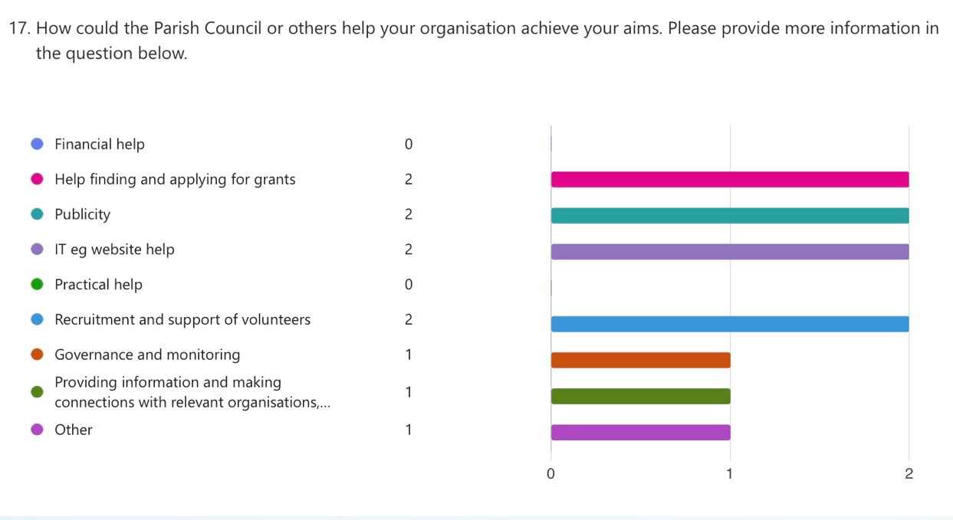

Further information
Over60s | Help with publicity
Transport Working Group | Help finding and applying for grants  To raise the balance of the installation costs for the zebra crossing.
Wilbrahams Environment Group | Recruitment and support of volunteers  A new Website with email Notifications to spread the word about what is planned
Bridge club | Recruitment and support of volunteers
Patchwork and quilting group | Not increasing the hall hire charge.
Wilbrahams Social Club
Wilbrahams’ Community Choir | IT eg website help  Financial donation for buying music Help to set up a website
Wilbrahams' Memorial Hall | Publicity  We maintain an informative website with a digital booking facility but we can only post news once a month and do not reach nearly the number of people that the previous Parish Council website did with their notification system. We use Facebook, which reaches a proportion of the village. We strongly believe that a central village calendar and news website would benefit the Hall but also other community groups to coordinate events. We think only the Parish Councils could realistically do this and it would really benefit the community.
Great Wilbraham Guild of Change Ringers | IT eg website help
Wilbrahams Sports Club | We currently deal in house with all those challenging issues listed above. If we need help in the future, it would be comforting to know that the Parish Council would be supportive not least because we are working for the same community.
The Wilbrahams and Six Mile Bottom Vegetable Flower and Produce Show
Well-brahams | Help finding and applying for grants
Great Wilbraham Common Rightsholders | Governance and monitoring  Continued engagement to ensure the special site is fully understood and well maintained
Wilbraham Rivers Protection | Providing information and making connections with relevant organisations, groups and individuals
Scrabble Club | I believe I’m correct in saying that Shirley Morley and her family Set up the tables etc for us. So we thank them very much.

